US Honors
Big Business in the Gilded Age DBQ
Directions:
From 1870 to 1900, corporations grew significantly in number, size, and influence in the United States. Analyze the impact of big business on the economy and politics and the responses of Americans to these changes. Use the following information to answer the questions.

Document 1:
The railroad president is a railroad king, whose whim is law. He collects tithes by reducing wages as remorselessly as the Shah of Persia or the Sultan of Turkey, and, like them, is not amenable to any human power. He can discharge (banish) any employee without cause. . . . He can withhold their lawful wages. He can delay trial on a suit at law, and postpone judgment indefinitely. He can control legislative bodies, dictate legislation, subsidize the press, and corrupt the moral sense of the community. He can fix the price of freights, and thus command the food and fuel-supplies of the nation. In his right hand he holds the government; in his left hand, the people.
~ Source: George E. McNeill, labor leader, The Labor Movement: The Problem of Today,
1887.

Question:
How is the railroad president like a king or a Shah or a Sultan? _________________________________________________________________________________________________________________________

_________________________________________________________________________________________________________________________

_________________________________________________________________________________________________________________________

Document 2:
[T]he modern manufacturing system has been brought into a condition analogous to that of a military organization, in which the individual no longer works as independently as formerly, but as a private in the ranks, obeying orders, keeping step, as it were, to the tap of the drum, and having nothing to say as to the plan of his work, of its final completion, or of its ultimate use and distribution. In short, the people who work in the modern factory are, as a rule, taught to do one thing – to perform one and generally a simple operation; and when there is no more of that kind of work to do, they are in a measure helpless. The result has been that the individualism or independence of the producer in manufacturing has been in a great degree destroyed, and with it has also in a great degree been destroyed the pride which the workman formerly took in his work – that fertility of resource which formerly was a special characteristic of American workmen, and that element of skill that comes from long and varied practice and reflection and responsibility.
~ Source: David A. Wells, engineer and economist, Recent Economic Changes and Their
Effect on the Production and Distribution of Wealth and the Well-Being of Society, 1889.

Question:
How is the modern manufacturing system like a military organization and what have workers lost?

_________________________________________________________________________________________________________________________

_________________________________________________________________________________________________________________________

_____________________________________________________________________________________________________________________________________________________________________________________

Document 3:
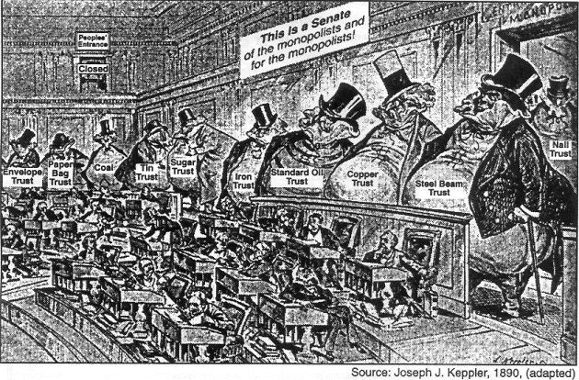
Source: Joseph Keppler, “The Bosses of the Senate,” Puck, January 23, 1889.

Question:
What is the political cartoon suggesting about the U.S. Senate and the power of big business in government? _________________________________________________________________________________________________________________________

_________________________________________________________________________________________________________________________

Document 4:
This, then, is held to be the duty of the man of Wealth: First, to set an example of modest, unostentatious living, shunning display or extravagance; to provide moderately for the legitimate wants of those dependent upon him; and after doing so to consider all surplus revenues which come to him simply as trust funds, which he is called upon to administer, and strictly bound as a matter of duty to administer in the manner which, in his judgment, is best calculated to produce the most beneficial results for the community – the man of wealth thus becoming the mere agent and trustee for his poorer brethren, bringing to their service his superior wisdom, experience, and ability to administer, doing for them better than they would or could do for themselves.
Source: Andrew Carnegie, “Wealth,” North American Review, June 1889.

Question:
According to Andrew Carnegie what must men of wealth do? _________________________________________________________________________________________________________________________

_________________________________________________________________________________________________________________________

Document 5:
[W]e seek to restore the government of the Republic to the hands of “the plain people,” with which class it originated…Our country finds itself confronted by conditions for which there is no precedent in the history of the world;…We pledge ourselves that if given power we will labor to correct these evils by wise and reasonable legislation, in accordance with the terms of our platform. We believe that the power of government – in other words, of the people – should be expanded (as in the case of the postal service) as rapidly and as far as the good sense of an intelligent people and the teaching of experience shall justify, to the end that oppression, injustice, and poverty shall eventually cease in the land.
Source: “People’s Party Platform,” Omaha Morning World-Herald, July 5, 1892.

Question:
What is the promise of the People’s Party? _________________________________________________________________________________________________________________________

_________________________________________________________________________________________________________________________

Document 6:
The organized working men and women, the producers of the wealth of the world, declare that men, women and children, with human brains and hearts, should have a better consideration than inanimate and dormant things, usually known under the euphonious title of “Property.”…
We demand a reduction of the hours of labor, which would give a due share of work and wages to the reserve army of labor and eliminate many of the worst abuses of the industrial system now filling our poor houses and jails…
Labor…insists upon the exercise of the right to organize for self and mutual protection.
…That the lives and limbs of the wage-workers shall be regarded as sacred as those of all others of our fellow human beings; that an injury or destruction of either by reason of negligence or maliciousness of another, shall not leave him without redress simply because he is a wage-worker…
And by no means the least demand of the Trade Unions is for adequate wages.
Source: Samuel Gompers, What Does Labor Want; an address before the International
Labor Congress in Chicago, August 28, 1893.
Question: According to Samuel Gompers, what do unionists want? _________________________________________________________________________________________________________________________

_________________________________________________________________________________________________________________________

Document 7:
“I am but one of many victims of Rockefeller’s colossal combination,” said Mr. [George]
Rice, “and my story is not essentially different from the rest…I established what was known as the Ohio Oil Works…I found to my surprise at first, though I afterward understood it perfectly, that the Standard Oil Company was offering the same quality of oil at much lower prices than I could do – from one to three cents a gallon less than I could possibly sell it for. I sought for the reason and found that the railroads were in league with the Standard Oil concern at every point, giving it discriminating rates and privileges of all kinds as against myself and all outside competitors.”
Source: George Rice, “How I Was Ruined by Rockefeller,” New York World, October 16, 1898.

Question: How did Standard Oil eliminate its competition? _________________________________________________________________________________________________________________________

_________________________________________________________________________________________________________________________

_________________________________________________________________________________________________________________________

Document 8:
[Department stores] were along the line of the most effective retail organization, with hundreds of stores coordinated into one and laid out upon the most imposing and economic basis. They were handsome, bustling, successful affairs, with a host of clerks and a swarm of patrons. Carrie passed along the busy aisles, much affected by the remarkable displays of trinkets, dress goods, stationery, and jewelry. Each separate counter was a showplace of dazzling interest and attraction. She could not help feeling the claim of each trinket and valuable upon her personally.
Source: Theodore Dreiser, Sister Carrie, a novel, 1900.

Question:
How did the department stores increase Carrie’s desire to consume goods?

_________________________________________________________________________________________________________________________

_________________________________________________________________________________________________________________________

Document 9:
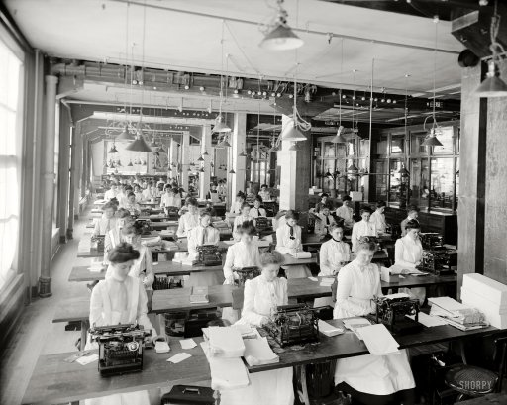
What does the image reveal about female labor?

_________________________________________

_________________________________________

_________________________________________

_________________________________________

_________________________________________

DBQ Prompt:
Use the documents as evidence to support your thesis. Analyze the impact (positives and negatives) of big business on the economy and politics in the United States during the period of 1870-1900.

The body of your essay should look something like this:

Introduction:
Introduce the topic in a unique and interesting way.

Do not restate the essay prompt.

Thesis statement – Usually in the last sentence

Body of the Essay:

Economics

1 paragraph per document
Body of the Essay Cont.:

Politics

1 paragraph per document
Conclusion:

Revisit the ideas in the thesis statement but DO NOT restate the thesis statement.

Helpful Hints:
- Do not use personal pronouns (I, you, we, etc.)
- Never write “I think” or “I believe”.
-Don’t use the phrase, “in conclusion”.
-Do not use lists (first, next, then)
-Be sure to cite documents within the essay (doc.1) and highlight them or bold them, or do something to make them stand out from the rest of your essay.
-Please underline or highlight your thesis statement.

Thesis | /4
Uses at least 6 documents  (Cite them and use them to support your thesis) | /6
Content  (Information from documents, with your analysis/interpretation of their meaning as they relate to your thesis) | /20
Conventions  (Spelling, grammar, sentence fluency, format, TD112) | /10
TOTAL | /40

