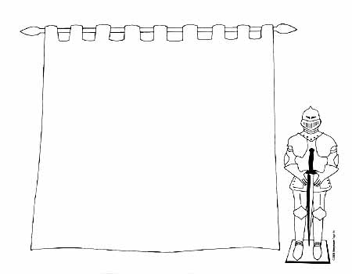

Coat of Arm Assignment Sheet

*AKS 37: Analyze European Medieval Society with regard to culture, politics, society, and economics.*

The bearing of a coat of arms is a great and positive influence on a family because, for its very purpose, it represents family unity. It gives the individual a sense of place and belonging to a family and it encourages the social structure of family, its values, honor, and service to society.

As a coat of arms is displayed, it serves as a constant reminder to bearers of that name of their ongoing responsibility to add meaning and honor to their family name. It graphically represents a proud relationship with their family’s heritage. It serves as a visible reminder of a relationship between past, present, and future generations.

**PROJECT: Your mission is to create your own design.** Your project will be in three parts.

* ***First (page 1)* –** On a separate sheet of paper answer the following questions as best you can, in complete sentences, concerning yourself and your family. (Write neatly or type)

1. What is your family name?
2. Where are your ancestors from [country/region] ?
3. What characteristics best describe your family? [past and present] How would you describe your family to others?
4. What colors best represent your family’s characteristics? Why?
5. If your family had a motto, what would it be? Why?
6. What animal would best represent your family? Why?
7. What symbol best represents you and your family? Why?
8. What information would you like for people to know about you? About your family?

* *Second (page 2)* **–** Now, using the information you developed in part one, design a “Coat of Arms” that expresses as many of the attributes that you identified in part one as possible.  
   You need a minimum of: 3 colors and 2 symbols/animals.
* *Third (page 3)* **–** In two to three paragraphs, explain how your “Coat of Arms” demonstrates/explains you and your family’s values that you want everyone to know and understand when they see your “Coat of Arms”.

Coat of Arm Assignment Sheet

*AKS 37: Analyze European Medieval Society with regard to culture, politics, society, and economics.*

The bearing of a coat of arms is a great and positive influence on a family because, for its very purpose, it represents family unity. It gives the individual a sense of place and belonging to a family and it encourages the social structure of family, its values, honor, and service to society.

As a coat of arms is displayed, it serves as a constant reminder to bearers of that name of their ongoing responsibility to add meaning and honor to their family name. It graphically represents a proud relationship with their family’s heritage. It serves as a visible reminder of a relationship between past, present, and future generations.

**PROJECT: Your mission is to create your own design.** Your project will be in three parts.

* ***First (page 1)* –** On a separate sheet of paper answer the following questions as best you can, in complete sentences, concerning yourself and your family. (Write neatly or type)

1. What is your family name?
2. Where are your ancestors from [country/region] ?
3. What characteristics best describe your family? [past and present] How would you describe your family to others?
4. What colors best represent your family’s characteristics? Why?
5. If your family had a motto, what would it be? Why?
6. What animal would best represent your family? Why?
7. What symbol best represents you and your family? Why?
8. What information would you like for people to know about you? About your family?

.

* ***Second (page 2)*** – Now, using the information you developed in part one, design a “Coat of Arms” that expresses as many of the attributes that you identified in part one as possible.  
   You need a minimum of: 3 colors and 2 symbols/animals.
* ***Third (page 3)*** – In two to three paragraphs, explain how your “Coat of Arms” demonstrates/EXPLAINS you and your family’s values that you want everyone to know and understand when they see your “Coat of Arms”.