Geography Final Study Guide

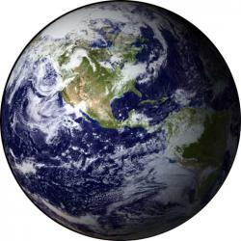
The items below are on your test. If you know each of these items you should do well on your final. It is all multiple choice. You will also complete a mental map.

What is Geography? Why is it important?

Mental, political, & physical maps

Latitude/Longitude: How to find them and what they are. Also know the zero degree lines for each
-Lat. is flat, Long. Is tall
-Prime Meridian & Equator

Absolute/ Relative Location—Know the location of the Arctic Circle, Tropics, Equator etc.

Map Parts: Legend, compass rose, scale and what they are used for
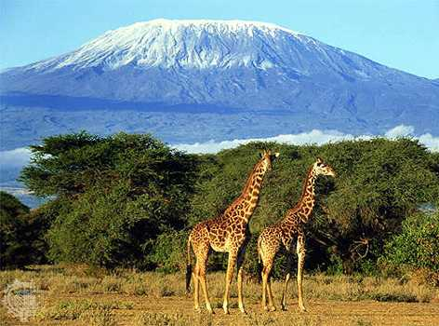
-Map distortion: 2 ways that maps can be distorted

What causes seasons on the earth? Tilt and rotation
-Solstice
-Equinox
-Arctic Circle
-Tropic of Cancer and Capricorn
***What are the above items and how do they work?

Climate types and characteristics:
-Orographic effect
-Ocean currents
-Global warming
-Know ALL climate types (Highland, Arid, Tropical wet, etc.)

How to read climate graphs, maps, and population pyramids

Settlement: Why do people settle where they settle?? Things that influence settlement:

Landforms, Location, Climate, Resources, Trade, Defense:
-Landforms—know the different landform types
-Natural resources: renewable vs. non-renewable
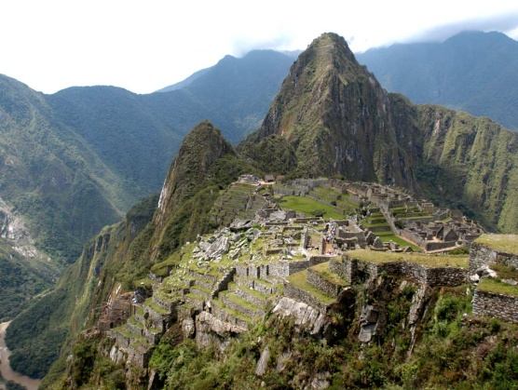
Plate tectonics, weathering, and erosion

Demography: Birth, Death, Literacy etc.
-Population pyramids
-Globalization
-MDCs vs. LDCs

Population Issues:
-Urbanization/Favelas (Also know what Primate Cities are)
-Indian Slums
-China’s One-Child Policy

Movement:
-Migration (emigrant vs. immigrant)
-Push/pull factors
-Immigration
-Drug Trafficking

Government/Economic Types:
-Government: Communism, Totalitarian, Democracy, Anarchy, etc) KNOW GOVERNMENT TYPES!!
-Economic Systems: Command vs. Market Economies (Capitalism, Socialism, Communism)
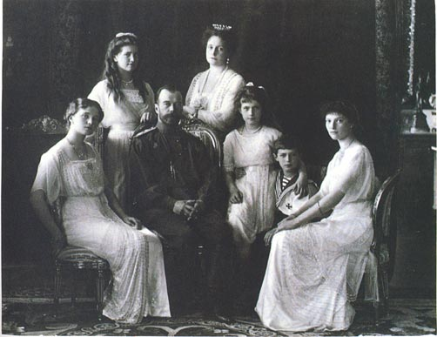
-Communism in Russia:
-Explain the different between Communism, Capitalism, and Socialism
-Who makes the decisions?
-Who owns the means of production?
-Lenin, Stalin
-History of: Czars, Anastasia, Revolution
-Traditional, Market (Capitalism), Mixed (Socialism), Command (Communism)
-Know how each functions, similarities and differences between them

Culture:
-Definition, examples of culture traits
-Diffusion (how culture spreads)
-Acculturation, Assimilation
-Innovation
-Traditionalism vs. Fundamentalism

World Religions: Islam, Judaism, Christianity, Buddhism, Hinduism:
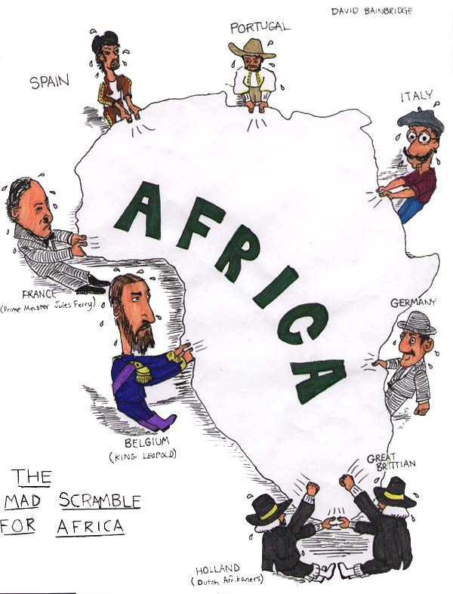
-Know the major beliefs of each religion, as well as how they are alike and different from each other
-Religious Conflicts: N. Ireland Bloody Sunday
-(Catholics vs. Protestants)
-Israel (Muslims vs. Jews)

Human-Environment Interaction:
-Deforestation/Rainforest
-Why is the Rainforest valuable?
-Results of deforestation
-Desalinization (Middle East)
-Benefits/Downfalls
-Why do it?
-Desertification (Sahara Desert)
-Define and give causes

