Calvin & Staheli

Name _________________________________________________ Date ___________________________________ Period __________

Immigration Primary Source Analysis

Doc. 1
Graph and Chart come from Ellis Island Records

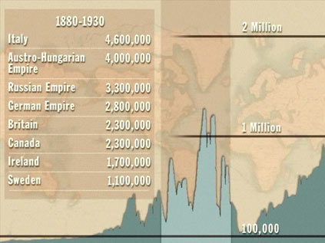

pre-1790 1820------1880 1880-1930 1930 ---- 2000

- According to the graph, which were the top four countries from which incoming immigrants arrived during the period 1880-1930?

- In what ways would the challenges of these immigrants be different from earlier immigrants to the United States?

- How did immigration during the period of 1880-1930 compare to periods both before and after it?

Doc. 2
The New Colossus by Emma Lazarus, on the Statue of Liberty
Note: The original Colossus of Rhodes was one of the wonders of the ancient world. It was one of the tallest statues of its time and its feet stood on pillars above the water (and was destroyed by an earthquake)

Not like the brazen giant of Greek fame,
With conquering limbs astride from land to land;
Here at our sea-washed, sunset gates shall stand
A mighty woman with a torch, whose flame
Is the imprisoned lightning, and her name
Mother of Exiles. From her beacon-hand
Glows world-wide welcome; her mild eyes command
The air-bridged harbor that twin cities frame.
"Keep, ancient lands, your storied pomp!" cries she
With silent lips. "Give me your tired, your poor,
Your huddled masses yearning to breathe free,
The wretched refuse of your teeming shore.
Send these, the homeless, tempest-tossed to me,
I lift my lamp beside the golden door!"

- According to this poem, how will immigrants be treated upon arriving in America?

Doc 3:
Antanas Laztauski, Lithuanian immigrant, autobiography

That first night we sat around in the house and they asked me, well, why did you come? I told them about that first night and what the ugly shoemaker said about life, liberty and the getting of happiness. They all leaned back and laughed what you need is money, they said it was all right at home. You wanted nothing. You ate your own meat and your own things on the farm. You made your own clothes and had your own leather. The other things you got at the Jew man's store and paid him with sacks of rye. But here you want a hundred things. Whenever you walk out you see new things you want, and you must have money to buy everything . . .. The next morning my friends woke me up at five o'clock and said, Now, if you want life, liberty and happiness, they laughed, you must push for yourself. You must get a job. Come with us.

- According to Doc. 3, how is life in America different from what the immigrant expected?

Doc. 4
Photograph of tenement housing
*A tenement is a house or apartment building that is divided into multiple living spaces for several different families. The term has the negative connotation of being run-down and overcrowded

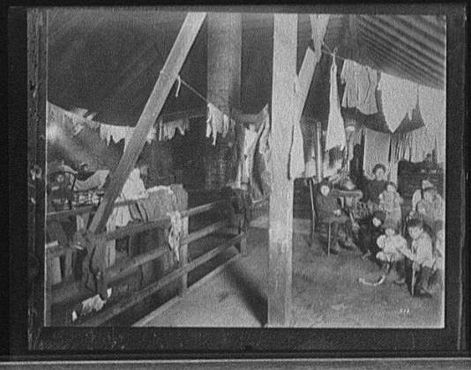

- Using the picture, describe what living conditions were like for many immigrants.

Doc. 5:
Political Cartoon entitled “Stop!” Birmingham Age Herald – Nov. 8, 1919

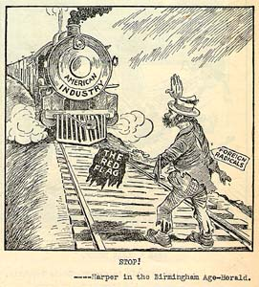

- According to this cartoon, how will immigrants affect the U.S. economy?

- Using the imagery in the cartoon, what are the artist’s feelings regarding immigrants?

- What is implied by the red flag the immigrant is holding?

Doc. 6:
“Life in a Social Settlement Hull House, Chicago.” Article by Alzina Parsons Sephens, March 1899.

There are now forty-seven evening classes meeting at the House weekly, twenty-five evening clubs for adults, seventeen afternoon clubs for children, the Hull-House Music School, a choral society for adults, a children's chorus, a children's sewing school, a training school for kindergartners, a trades union for young women. In daily use are the nursery, the kindergarten, the playground, the penny provident bank, an employment bureau, a sub-station of the Chicago post office. A trained nurse reports to the house every morning and noon, to take charge of the sick calls for the neighborhood; a kindergartner visits daily sick and crippled children. The coffeehouse serves an average of 250 meals daily, and furnishes noonday lunches to a number of women's clubs; soups and broths and wholesome food are bought by neighbors from its kitchen, and bread from its bakery, adorned with the label of the bakers' unions, goes out to the Lewis Institute, to grocery stores, to neighbors' tables.

- Using the statement in Doc. 6, describe at least four different services that were provided for the poor by Hull House in Chicago.

- How does the author feel about immigrants in the United States?

- What are these services designed to do?

Doc. 7:
“Shut the Door” Speech by Senator Ellison DuRant Smith in support of an act that limited immigration to the United States

We have been called the melting pot of the world. We had an experience just a few years ago, during the great World War, when it looked as though we had allowed influences to enter our borders that were about to melt the pot in place of us being the melting pot. I think that we have sufficient stock in America now for us to shut the door, Americanize what we have, and save the resources of America for the natural increase of our population. We all know that one of the most prolific causes of war is the desire for increased land ownership for the overflow of a congested population. We are increasing at such a rate that in the natural course of things in a comparatively few years the landed resources, the natural resources of the country, shall be taken up by the natural increase of our population . . .. Without offense, but with regard to the salvation of our own, let us shut the door and assimilate what we have, and let us breed pure American citizens and develop our own American resources.
- From the speech in Doc. 7, please identify at least two reasons why immigration should be restricted.

- What should be done with immigrants already in the United States?

