Name: Period:

Religious Conflicts Notes

Bloody Sunday
Where? When?
Who’s fighting who?
Why?
Describe Bloody Sunday
Result?
Name: Period:
Israel & Palestine Notes
Scenario: | 1. | 2. | 3.
Background: | - The Hebrew (Jewish) people have lived in Israel since the 11th century BCE  - Many Old and New Testament stories were recorded while the Jews inhabited that area  - The Romans conquered the area and dominated the Jews  - The Roman Empire fell and Israel became part of the Byzantine Empire—the Jews were kicked out by the Byzantines  - The Palestinians came in and took over Israel  - Byzantine’s conquered by the Ottoman Empire and controlled by the Turks  - Christians tried to take back Israel during the Crusades, but the Turks maintained control  - England took control of Israel when the Ottoman Empire dissolved after WWI  - After the persecution of the Jews during WWII, the Zionism movement pushed for the Jews to have their own homeland  - 1948: the UN kicked the Palestinians out and created the state of Israel to give the Jews a homeland. That displaced the Palestinians, moving them to the surrounding countries, causing them to fight for possession of Israel
Israel or Palestine?
Modern Israel: | 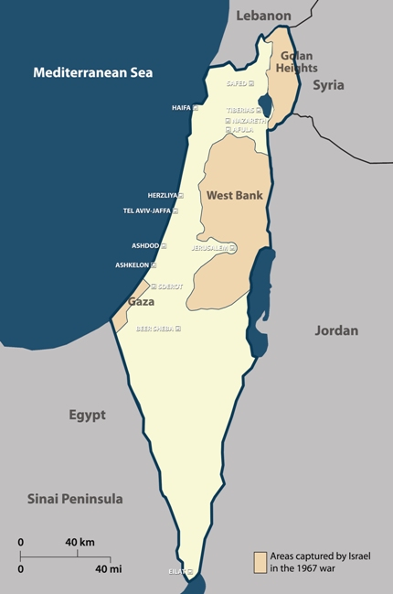  Golan Heights:  West Bank:  Palestinians:
Israel & Palestine Today:
The Separation Wall:
What do you think?

