1920s Culture War Information
The Ku Klux Klan
After the Civil War, the Ku Klux Klan, led by former Confederate General Nathaniel Bedford Forrest, used terrorist tactics to intimidate former slaves. A new version of the Ku Klux Klan arose during the early 1920s. Throughout this time period, immigration, fear of radicalism, and a revolution in morals and manners fanned anxiety in large parts of the country. Roman Catholics, Jews, African Americans, and foreigners were only the most obvious targets of the Klan's fear-mongering. Bootleggers and divorcees were also targets.
Contributing to the Klan's growth was a post-war depression in agriculture, the migration of African Americans into northern cities, and a swelling of religious bigotry and nativism in the years after World War I. Klan members considered themselves defenders of Prohibition, traditional morality, and true Americanism. The Klan efforts were directed against African Americans, Jews, Catholics, and immigrants.
In 1920, two Atlanta publicists, Edward Clarke, a former Atlanta journalist, and Bessie Tyler, a former madam, took over an organization that had formed to promote World War I fund drives. At that time, the organization had 3,000 members. In three years they built it into the Southern Publicity Association, a national organization with three million members. After the war, they bolstered membership in the Klan by giving Klansmen part of the $10 induction fee of every new member they signed up.
During the early 1920s, the Klan helped elect 16 U.S. Senators and many Representatives and local officials. By 1924, when the Klan had reached its peak in numbers and influence, it claimed to control 24 of the nation's 48 state legislatures. That year it succeeded in blocking the nomination of Al Smith, a New York Catholic, at the Democratic National Convention.
The three million members of the Klan after World War I were quite open in their activities. Many were small-business owners, independent professionals, clerical workers, and farmers. Members marched in parades, patronized Klan merchants, and voted for Klan-endorsed political candidates. The Klan was particularly strong in the Deep South, Oklahoma, and Indiana. Historians once considered the Ku Klux Klan a group of marginal misfits, rural traditionalists unable to cope with the coming of a modern urban society. But recent scholarship shows that Klan members were a cross-section of native Protestants; many were women, and many came from urban areas.
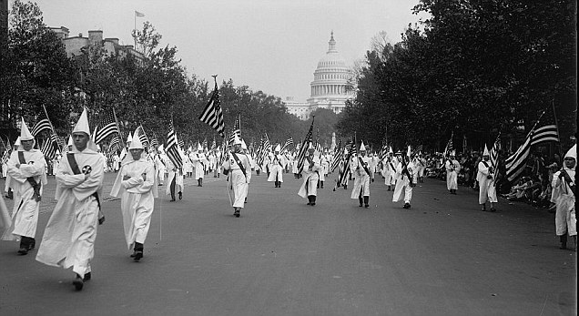
Immigration Restriction
Before World War I, American industry, steamship companies, and railroads promoted immigration and financed groups opposed to immigration restriction. The United States did institute registration and literacy requirements for immigrants; yet, opponents of restriction succeeded in blocking efforts to establish immigration quotas.
World War I revealed that the economy could function effectively without foreign immigration; opposition to immigration restriction withered away. Not only had World War I demonstrated that immigrants had become "Americanized," but with the establishment of new European nation states, interest in European politics faded away. While some opponents of immigration argued that it threatened the nation's culture, most of the arguments advanced against immigration were economic. Among the chief proponents of immigration restriction were the unions of the American Federation of Labor. Organized labor feared that American workers' wages would decline if unskilled immigrant workers flooded the labor market. Meanwhile, many businessmen feared dangerous foreign radicals.
During the 1920s, most ethnic groups agreed that the overall volume of immigration should be reduced. The issue remained: how to distribute the immigration quotas. A compromise was easily reached: make the quotas proportionate to the current population, so that future immigration would not change the balance of ethnic groups.
In 1924, Congress reduced the number of immigrants allowed into the United States each year to two percent of each nationality group counted in the 1890 census. It also barred Asians entirely.

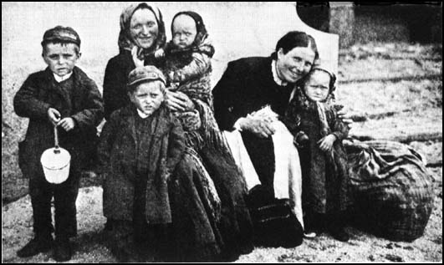

Fundamentalism and Pentecostalism
Religion was a pivotal cultural battleground during the 1920s. The roots of this religious conflict were planted in the late 19th century. Before the Civil War, the Protestant denominations were united in a belief that the findings of science confirmed the teachings of religion. But during the 1870s, a lasting division had occurred in American Protestantism over Charles Darwin's theory of evolution. Religious modernists argued that religion had to be accommodated to the teachings of science, while religious traditionalists sought to preserve the basic tenets of their religious faith.
Pentecostalism, another current in Protestant revivalism, began on New Year's Day in 1901. A female student at Bethel Bible College in Topeka, Kansas, began speaking in tongues, unintelligible speech that accompanies religious excitation. To many evangelicals, speaking in tongues was evidence of the descent of the Holy Spirit into a believer.
Pentecostals rejected the idea that the age of miracles had ended. During the 1920s, many Americans became aware of Pentecostalism as charismatic faith healers claimed to be able to cure the sick and to allow the crippled to throw away their crutches. Pentecostalism spread particularly rapidly among lower middle-class and poorer Protestants who sought a more spontaneous and emotional religious experience than that offered by the mainstream religious denominations. The most prominent of the early Pentecostal revivalists was Aimee Semple McPherson.
The Fundamentalist and Pentecostal movements arose in the early 20th century as a backlash against modernism, secularism, and scientific teachings that contradicted their religious beliefs. Early fundamentalist doctrine attacked competing religions--especially Catholicism, which it portrayed as an agent of the Antichrist--and insisted on the literal truth of the Bible, a strict return to fundamental principles, and a thoroughgoing rejection of modernity.
Between 1921 and 1929, Fundamentalists introduced 37 anti-evolution bills into 20 state legislatures. The first law to pass was in Tennessee.
During the summer of 1925, John Scopes, a high school teacher in Dayton, Tennessee, was tried for violating the prohibition on the teaching of evolution in tax-supported schools. The statute forbade the teaching in public schools of any scientific theory that denied the literalness of the Biblical account of creation. The Scopes case raised the legal issue of the validity of a law that seemed to violate the constitutional separation of church and state.
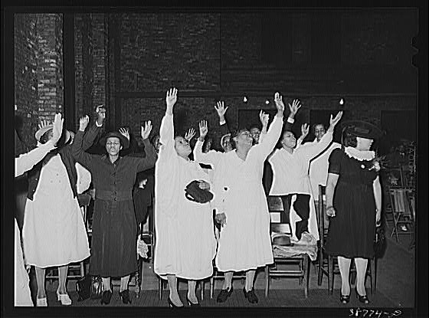

The Scopes Trial
In the summer of 1925, a young schoolteacher named John Scopes stood trial in Dayton, Tennessee, for violating the state law against the teaching of evolution. Two of the country's most famous attorneys faced off in the trial. William Jennings Bryan, 65 years old and a three time Democratic presidential nominee, prosecuted; 67-year-old Clarence Darrow, who was a staunch agnostic. Bryan declared that "the contest between evolution and Christianity is a duel to the death."
George Rappelyea, a Dayton, Tenn., booster, realized that the town would get enormous attention if a local teacher was arrested for teaching evolution. He enlisted John Scopes, a science teacher and football coach, who arranged to teach from George Hunter's Civic Biology, a high school textbook promoting Charles Darwin's arguments in The Descent of Man.
The trial was marked by hoopla and a carnival-like atmosphere. Thousands of people swelled the town of a thousand. For 12 days in July, 1925, 100 reporters sent dispatches.
The trial judge had prohibited the defense from using scientists as witnesses. So, on the trial's seventh day, the defense team called Bryan to testify as an expert on the Bible. Darrow subjected Bryan to a withering cross-examination. He got Bryan to say that Creation was not completed in a week, but over a period of time that "might have continued for millions of years."
Bryan opposed the mandated teaching of evolution in public schools because he thought the people should exercise local control over school curricula. He also opposed Darwin's theory of evolution by natural selection because these ideas had been used to defend laissez-faire capitalism on the grounds that a perfectly free market promotes the "survival of the fittest." As early as 1904, Bryan had denounced social Darwinism as "the merciless law by which the strong crowd out and kill off the weak."
Not a Biblical literalist, Bryan was aware of serious scientific difficulties with Darwinism, such as Darwin's theory that slight, random variations were enough to generate life from non-life to produce a vast array of biological species. But Bryan mistook the lack of consensus about the mechanisms that Darwin advanced to explain the evolutionary process for a lack of scientific support for the concept of evolution itself.
The day after this exchange, Darrow changed his client's plea to guilty. Scopes was convicted and fined $100. However, the conviction was thrown out on a technicality by the Tennessee Supreme Court: that the judge, and not the jury, had determined the $100 fine. In 1967, the Supreme Court struck down Tennessee's anti-evolution law for violating the Constitution's prohibition against the establishment of religion.
The Scopes trial resulted in two enduring conclusions: that legislatures should not restrain the freedom of scientific inquiry and that society should respect academic freedom.
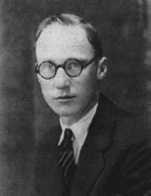
The Great Migration
The racial composition of the nation's cities underwent a decisive change during and after World War I. In 1910, three out of every four black Americans lived on farms, and nine out of ten lived in the South. World War I changed that profile. Hoping to escape tenant farming, sharecropping, and peonage, 1.5 million Southern blacks moved to cities. During the 1910s and 1920s, Chicago's black population grew by 148 percent; Cleveland's by 307 percent; Detroit's by 611 percent.
Access to housing became a major source of friction between blacks and whites during this massive movement of people. Many cities adopted residential segregation ordinances to keep blacks out of predominantly white neighborhoods. In 1917, the Supreme Court declared municipal resident segregation ordinances unconstitutional. In response, whites resorted to the restrictive covenant, a formal deed restriction binding white property owners in a given neighborhood not to sell to blacks. Whites who broke these agreements could be sued by "damaged" neighbors. Not until 1948 did the Supreme Court strike down restrictive covenants.
Confined to all-black neighborhoods, African Americans created cities-within-cities during the 1920s. The largest was Harlem, in upper Manhattan, where 200,000 African Americans lived in a neighborhood that had been virtually all-white 15 years before.
The Harlem Renaissance
The movement for black pride found its cultural expression in the Harlem Renaissance, the first self-conscious literary and artistic movement in African American history.
Signs of growing racial consciousness proliferated during the 1910s. Fifty new black newspapers and magazines appeared in that decade, bringing the total to 500. The Associated Negro Press, the first national black press agency, was founded in 1919. In 1915, Carter Woodson, a Harvard Ph.D., founded the first permanent Negro historical association, the Association for the Study of Negro Life and History, and began publication of the Journal of Negro History.
During the 1920s, Harlem became the capital of black America, attracting black intellectuals and artists from across the country and the Caribbean. Soon, the Harlem Renaissance was in full bloom. The poet Countee Cullen eloquently expressed black artists' long-suppressed desire to have their voices heard: "Yet do I marvel at a curious thing: To make a poet black, and bid him sing!"
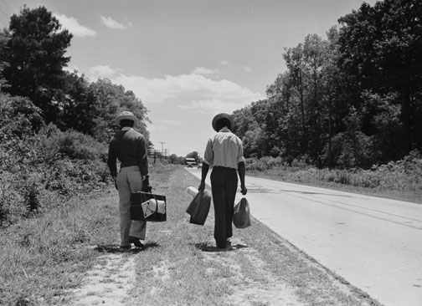
The Consumer Economy
Americans in the 1920s were the first to wear ready-made, exact-size clothing. They were the first to play electric phonographs, to use electric vacuum cleaners, to listen to commercial radio broadcasts, and to drink fresh orange juice year round. Cigarettes, cosmetics, and synthetic fabrics such as rayon became staples of American life. Newspaper gossip columns, illuminated billboards, and commercial airplane flights were novelties during the 1920s. The United States became a consumer society.
The automobile industry provided an enormous stimulus for the national economy. By 1929, the industry produced 12.7 percent of all manufacturing output, and employed one out of every 12 workers. Automobiles, in turn, stimulated the growth of steel, glass, and rubber industries, along with the gasoline stations, motor lodges, campgrounds, and hot dog stands that dotted the nation's roadways.
Alongside the automobile, the telephone and electricity also became emblems of the consumer economy. By 1930, two-thirds of all American households had electricity, and half of American households had telephones. As more and more of America's homes received electricity, new appliances followed: refrigerators, washing machines, vacuum cleaners, and toasters quickly took hold.
During the 1920s, advertising agencies hired psychologists to design the first campaigns. They touted products by building-up name brand identification, creating memorable slogans, manipulating endorsements by doctors or celebrities, and appealing to consumers' hunger for prestige and status. By 1929, American companies spent $3 billion annually to advertise their products--five times more than the amount spent on advertising in 1914.
Installment credit soared during the 1920s. Banks offered the country's first home mortgages. Manufacturers of everything--from cars to irons--allowed consumers to pay "on time." About 60 percent of all furniture and 75 percent of all radios were purchased on installment plans.
A fundamental shift took place in the American economy during the 1920s. The nation's families spent a declining proportion of their income on necessities (food, clothing, and utilities) and an increasing share on appliances, recreation, and a host of new consumer products. As a result, older industries, such as textiles, railroads, and steel, declined, while newer industries, such as appliances, automobiles, aviation, chemicals, entertainment, and processed foods, surged ahead rapidly.
During the 1920s, the chain store movement revolutionized retailing. Chains of stores multiplied across the country, like Woolworth's, the five-and-dime chain. The largest grocery chain, A&P, had 17,500 stores by 1928. Alongside drugstore and cigar store chains, there were also interlocking networks of banks and utility companies. These banks and utilities played a critical role in promoting the financial speculation of the late 1920s, which would be one of the causes for the Great Depression.
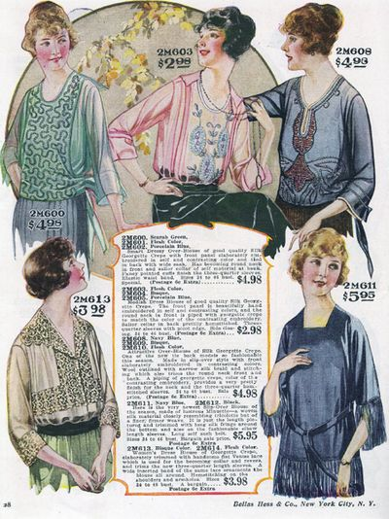
Mass Entertainment
Of all the new appliances to enter the nation's homes during the 1920s, none had a more revolutionary impact than the radio. Sales of radios soared from $60 million in 1922 to $426 million in 1929. The first commercial radio station began broadcasting in 1919, and during the 1920s, the nation's airwaves were filled with musical variety shows and comedies.
Radio drew the nation together by bringing news, entertainment, and advertisements to more than 10 million households by 1929. Radio blunted regional differences and imposed similar tastes and lifestyles. No other media had the power to create heroes and villains so quickly.
The single most significant new instrument of mass entertainment was the movies. Movie attendance soared, from 50 million a week in 1920 to 90 million weekly in 1929. According to one estimate, Americans spent 83 cents of every entertainment dollar going to the movies, and three-fourths of the population went to a movie theater every week.
The popularity of the movies soared as films increasingly featured glamour, sophistication, and sex appeal. New kinds of movie stars appeared: the mysterious sex goddess, personified by Greta Garbo; the passionate hot-blooded lover, epitomized by Rudolph Valentino; and the flapper, with her bobbed hair and skimpy skirts. New film genres also debuted, including swashbuckling adventures, sophisticated sex comedies, and tales of flaming youth and their new sexual freedom. Comedies, such as the slapstick masterpieces starring Charlie Chaplin and Buster Keaton, enjoyed great popularity as well.
Like radio, movies created a new popular culture with common speech, dress, behavior, and heroes. Like radio, Hollywood did its share to reinforce racial stereotypes by denigrating minority groups. The radio, the electric phonograph, and the silver screen both molded and mirrored mass culture.
Spectator sports attracted vast audiences in the 1920s. The country yearned for heroes in an increasingly impersonal, bureaucratic society, and sports provided them. Team sports flourished, however, Americans focused on individual superstars, people whose talents or personalities made them appear larger than life.
Baseball drew the largest crowds. With players like George Herman ("Babe") Ruth, the sport's undisputed superstar. Up until the 1920s, Ty Cobb's defensive brand of baseball, with its emphasis on base hits and stolen bases, had dominated the sport. Ruth transformed baseball into the game of the home-run hitter. In 1921, the New York Yankee slugger hit 59 home runs--more than any other team. In 1927, the "Sultan of Swat" hit 60 home runs.
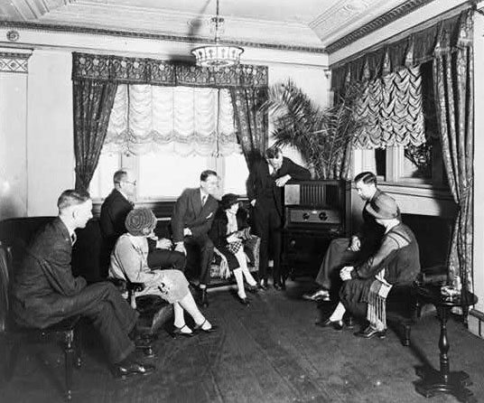
The Avant-Garde
Few decades have produced as many great works of art, music, or literature as the 1920s. At the decade's beginning, American culture stood in Europe's shadow. By the decade's end, Americans were leaders in the struggle to liberate the arts from older canons of taste, form, and style. It was during the 1920s that Eugene O'Neill, the country's most talented dramatist, wrote his greatest plays, and that authors William Faulkner, Ernest Hemingway, F. Scott Fitzgerald, and Thomas Wolfe published their first novels.
American poets of the 1920s, such as Hart Crane, E. E. Cummings, Countee Cullen, Langston Hughes, Edna St. Vincent Millay, and Wallace Stevens experimented with new styles of punctuation, rhyme, and form. Likewise, artists like Charles Demuth, Georgia O'Keeffe, and Joseph Stella challenged the dominant realist tradition in American art and pioneered non-representational and expressionist art forms.
During the 1920s, many of the nation's leading writers exposed the shallowness and narrow-mindedness of American life. The United States was a nation awash in materialism and devoid of spiritual vitality: "a wasteland," wrote the poet T.S. Eliot, "inhabited by hollow men." No author offered a more scathing attack on middle class boorishness and smugness than Sinclair Lewis, who in 1930 became the first American to win the Nobel Prize for Literature. In Main Street (1920) and Babbitt (1922), he satirized the narrow-minded complacency and dullness of small town America, while in Elmer Gantry (1922), he exposed religious hypocrisy and bigotry.
As editor of Mercury magazine, H.L. Mencken wrote hundreds of essays mocking practically every aspect of American life. Calling the South a "gargantuan paradise of the fourth rate," and the middle class the "booboisie," Mencken directed his choicest barbs at reformers, whom he blamed for the bloodshed of World War I and the gangsters of the 1920s. "If I am convinced of anything," he snarled, "it is that Doing Good is in bad taste."
The writer Gertrude Stein defined an important group of American intellectuals when she told Ernest Hemingway in 1921, "You are all a lost generation." Stein was referring to the expatriate novelists and artists who had participated in the Great War, only to emerge from the conflict convinced that it was an exercise in futility. In their novels, F. Scott Fitzgerald and Hemingway pointed toward a philosophy now known as "existentialism," which maintains that life has no transcendent purpose and that each individual must salvage personal meaning from the void. Hemingway's fiction lionized toughness and "manly virtues" as a counterpoint to the softness of American life. In The Sun Also Rises (1926) and A Farewell to Arms (1929), he emphasized meaningless death and the importance of facing stoically the absurdities of the universe. In the conclusion of The Great Gatsby (1925), Fitzgerald gave pointed expression to an existentialist outlook: "so we beat on, boats against the current, borne back ceaselessly into the past."
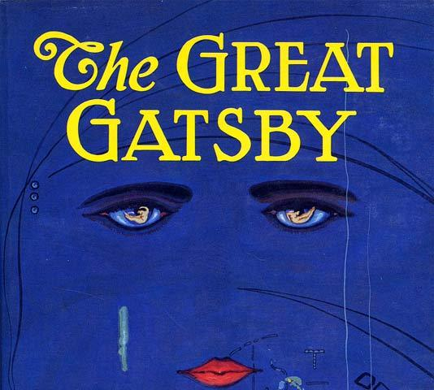
The New Woman
In 1920, after 72 years of struggle, American women received the right to vote. After the 19th Amendment passed, reformers talked about female voters uniting to clean up politics, improve society, and end discrimination.
At first, male politicians moved aggressively to court the women's vote, passing legislation guaranteeing women's rights to serve on juries and hold public office. Congress also passed legislation to set up a national system of women's and infant's health care clinics, as well as a constitutional amendment prohibiting child labor--a measure supported by many women's groups.
The early momentum quickly dissipated, however, as the women's movement divided within and faced growing hostility from without. The major issue that split feminists during the 1920s was a proposed Equal Rights Amendment to the Constitution outlawing discrimination based on sex. The issue pitted the interests of professional women against those of working class women, many of whom feared that the amendment would prohibit "protective legislation" that stipulated minimum wages and maximum hours for female workers.
Women did not win new opportunities in the workplace. Although the American work force included eight million women in 1920, more than half were black or foreign-born. Domestic service remained the largest occupation, followed by secretaries, typists, and clerks--all low-paying jobs. The American Federation of Labor (AFL) remained openly hostile to women because it did not want females competing for men's jobs. Female professionals, too, made little progress. They consistently received less pay than their male counterparts. Moreover, they were concentrated in traditionally "female" occupations such as teaching and nursing.
During the 1920s, the organized women's movement declined in influence, partly due to the rise of the new consumer culture that made the suffragists and settlement house workers of the Progressive era seem old-fashioned. Advertisers tried self-consciously to co-opt many of the themes of pre-World War I feminism, arguing that the modern economy was filled with exciting and liberating opportunities for consumption. To popularize smoking among women, advertisers staged parades down New York's 5th Avenue, imitating the suffrage marches of the 1910s in which young women carried "torches of freedom"--cigarettes.

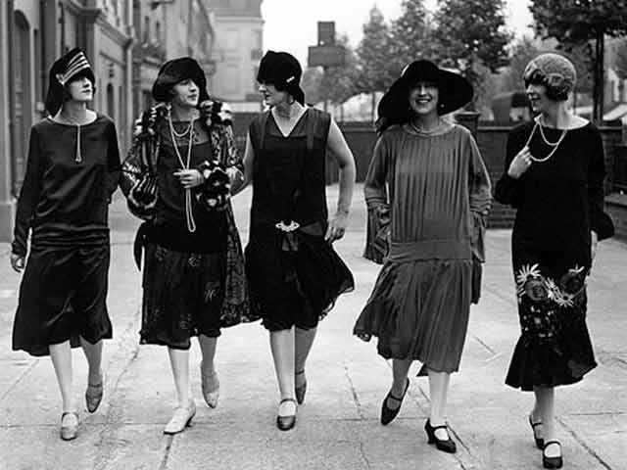

Sacco and Vanzetti

During the 20th century, a number of trials have excited widespread public interest. One of the first cause celebrities was the case of Nicola Sacco, a 32-year-old shoemaker, and Bartolomeo Vanzetti, a 29-year-old fish peddler, who were accused of double murder. On April 15, 1920, a paymaster and a payroll guard carrying a factory payroll of $15,776 were shot to death during a robbery in Braintree, Massachusetts, near Boston. About three weeks later, Sacco and Vanzetti were charged with the crime. Their trial aroused intense controversy because it was widely believed that the evidence against the men was flimsy, and that they were being prosecuted for their immigrant background and their radical political beliefs. Sacco and Vanzetti were Italian immigrants and avowed anarchists who advocated the violent overthrow of capitalism.
It was the height of the post-World War I Red Scare, and the atmosphere was seething with anxieties about Bolshevism, aliens, domestic bombings, and labor unrest. Revolutionary upheavals had been triggered by the war, and one-third of the U.S. population consisted of immigrants or the children of immigrants.
No witnesses had gotten a good look at the perpetrators of the murder and robbery. The witnesses described a shootout in the street and the robbers escaping in a Buick, scattering tacks to deter pursuers. Anti-immigrant and anti-radical sentiments led the police to focus on local anarchists.
Sacco and Vanzetti were followers of Luigi Galleani, a radical Italian anarchist who had instigated a wave of bombings against public officials just after World War I. Carlo Valdinoci, a close associate of Galleani, had blown himself up while trying to plant a bomb at Attorney General Palmer's house. Palmer's house was largely destroyed; the powerful blast hurled several neighbors from their beds in nearby homes. Though not injured, Palmer and his family were thoroughly shaken by the blast.
Police linked Sacco's gun to the double murder, the only piece of physical evidence that connected the men to the crime. The defense, however, argued that the link was overstated.
In 1921, Sacco and Vanzetti were convicted in a trial that was marred by prejudice against Italians, immigrants, and radical beliefs. The evidence was ambiguous as to the pairs' guilt or innocence, but the trial was a sham: the prosecution played heavily on the pairs' radical beliefs; the men were kept in an iron cage during the trial; the jury foreman muttered unflattering stereotypes about Italians. In his instructions to the jury, the presiding judge urged the jury to remember their "true American citizenship."
The pair was electrocuted in 1927. As the guards adjusted his straps, Vanzetti said in broken English: I wish to tell you I am innocent and never connected with any crime... I wish to forgive some people for what they are now doing to me.
Today, many historians now believe Sacco was probably guilty and Vanzetti was innocent but that the evidence was insufficient to convict either one.
