Geography Study Guide Explanations
(This is not a complete study guide. There may be questions asked on the final that are not on this review)
Mental Map: A person’s point of view or perception of the world. (Map you make in your mind)
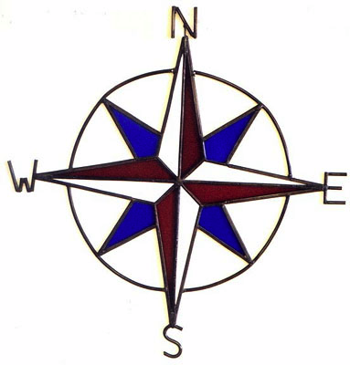
Parts of a map
Compass rose: tells you direction. North, South, East, West
Legend or key: shows what different symbols, colors represent.
Scale: measuring a certain distance on a map that represents actual distance on the ground
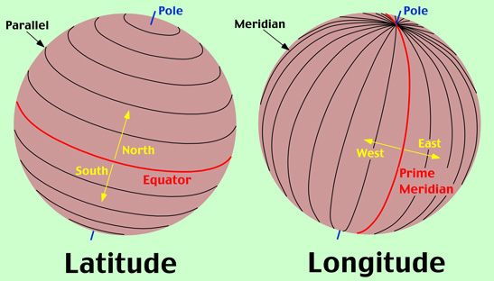
Location
Two types of location
1- Absolute: Find the Latitude and Longitude address
Latitude: Run east to west
Longitude: Run north to south
2-Relative: Where something is in relation to something else. (Example Portugal has a relative location west of Spain. Nevada has a relative location West of Utah and East of California)

Settlement
Why did people settle where they did? Access to water, fertile land and soil, comfortable mild climates, defense, close to rivers to trade and navigate

Seasons
What creates different seasons around the world? Tilt of the Earth on its axis and it’s revolution around the sun. Remember Tilt and location determine different seasons in different places.

Climate
Climate is the average weather in a place over time. (Measured by average rainfall and temperature.)
Weather is the day-to-day conditions.
There are many climate types around the world. Tropical, Dry (arid, semiarid) Mid-Latitudes (marine west coast, humid continental) and High Latitudes (Subarctic, Tundra, Highland)

Landforms
Peninsula, archipelago, mountain, cliff, canyon, gulf, plateau, delta, etc.

Processes that shape earth
Weathering, erosion, tectonic processes (moving of earth’s crust)
Plate Tectonics: Process where crust moves on the earth’s surface. (Creates mountains, valleys, earthquakes, volcanoes)

Renewable vs. Non renewable resources
1- Renewable Resources: Things that can replenish themselves- sunlight, water wind
2- Non- renewable: Things that can replenish themselves. Coal, petroleum, etc.

Population Pyramids
Shows the population of male and female in a particular country for each age group
Males on one side, Females on the other side.
Why do they look the way they do? What do they tell you about a population? They can tell you how fast or slow a population is growing. Use the examples below.
Which one represents a developing country? (LDC)
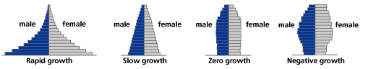

Government Types (How are countries governed, who’s in charge, etc)
Monarchy: “Rule by one” Rule of king or queen
Anarchy: Complete lack of political system
Republic: Elects representatives to make all government decisions
Totalitarian: Government is in “total” control. Can be a political party or dictator in power
Theocracy: “Rule by God” church leaders act as authority.
Dictatorship: Single, unelected leader. Usually uses force and coercion to keep control
Oligarchy: “Rule by few” Power rest in hands of a few elite
Constitutional Republic: United States is an example. We have a constitution and we have representative that we elect to make decisions for us.

Economic Systems- (How people make money, what they do, how they earn a living, etc)
1- Traditional/Subsistence: Most basic economic type. Do things by tradition or what others have done before you.
2- Market: (Example: Capitalism) People choose what to buy and sell. In a true market economy government has no involvement.
3- Mixed: (Example: Socialism) Mix of other economic types. U.S. is an example of mixed.
4- Command: (Example: Communism) Government makes all decisions on what to buy and sell

