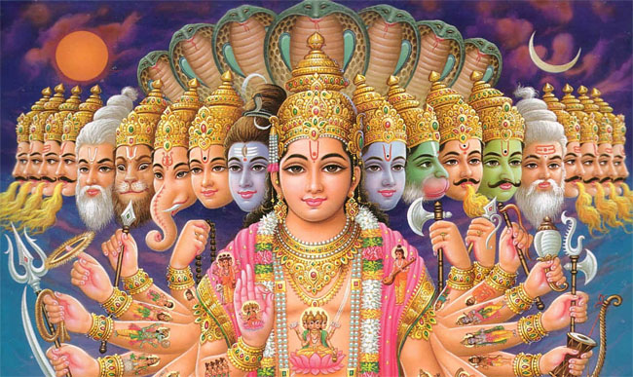
Name: Period:
Hinduism Notes
Origin
History
Who Practices Hinduism?
Hindu Worship
Hindu Festivals
Dharma
Reincarnation
Karma
Ganges River
Gods and Goddesses
The Caste System
Hindu Scriptures
Sikhism
Sikh Leaders and Church
Sikh Clothing and Appearance

Brahmins: Priests, teachers, judges
Kshatryias: Nobles/warriors
Vaishyas: Merchants and farmers
Sudras: Slaves, craft workers and Women
OUTCASTES: garbage collectors etc.

