Name: Period:

CO2: HOW MUCH DO YOU SPEW?

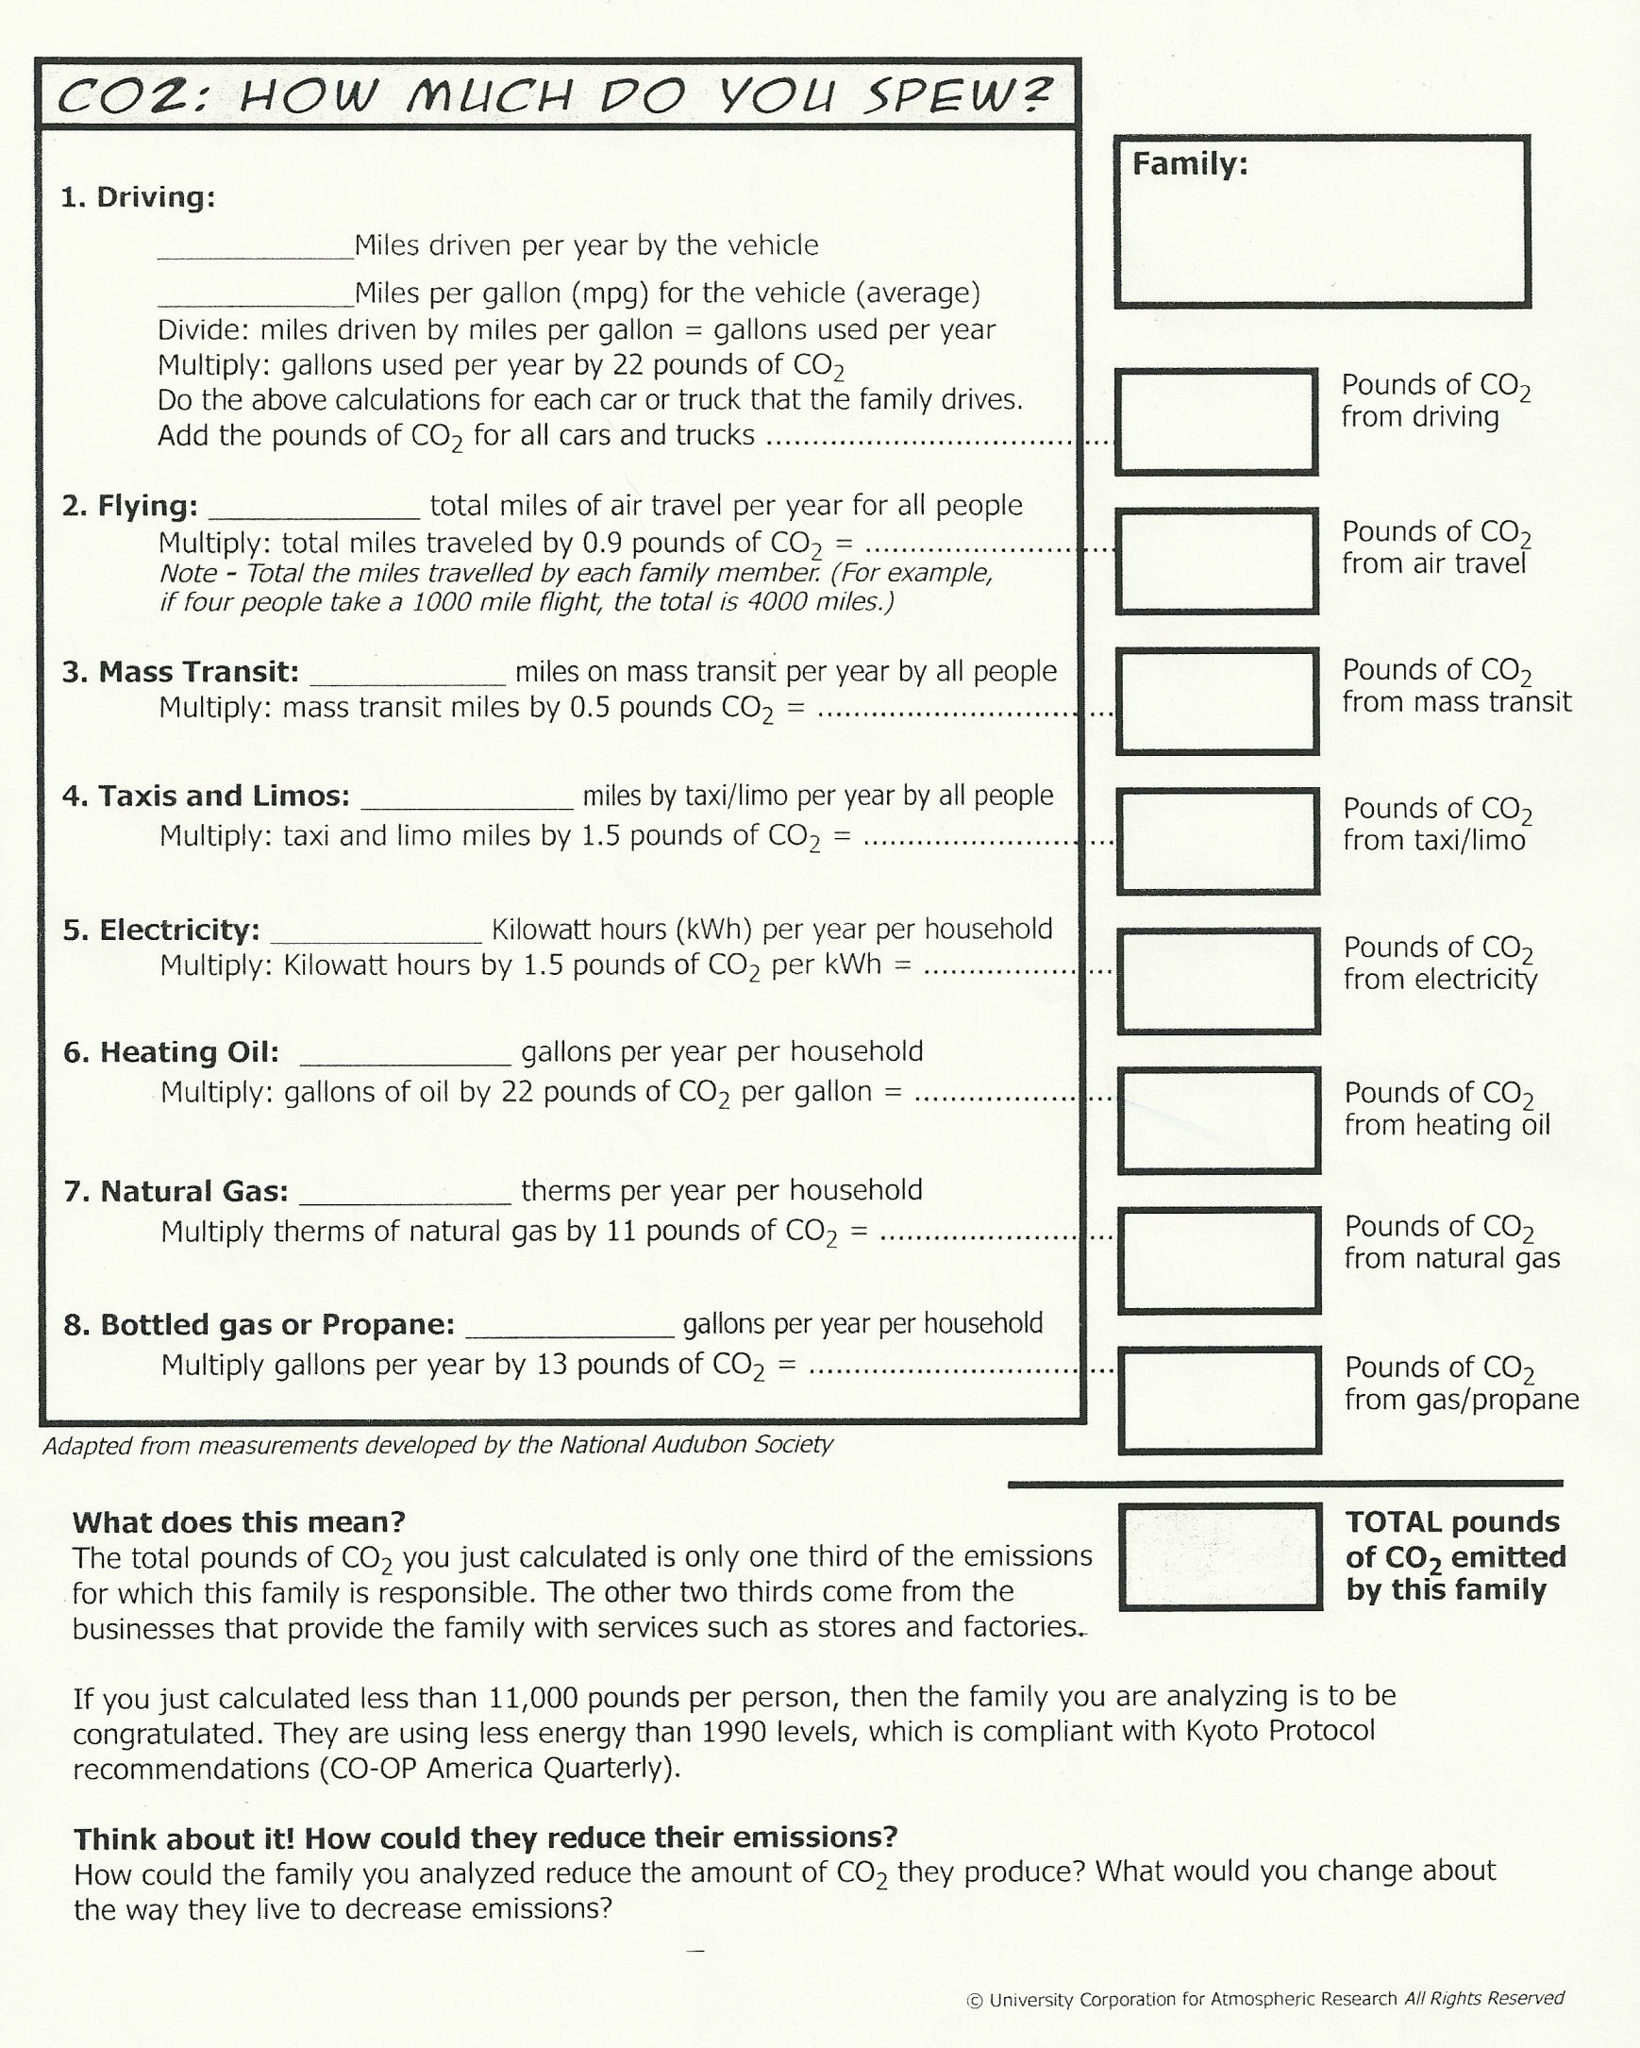
CO2: HOW MUCH DO YOU SPEW?

Directions: Answer the following questions after you have completed the CO2 activity

- The Kyoto Protocol recommended that emissions be reduced to at or below 1990 levels. That means less than 11,000 pounds of CO2 per person per year. Is the family you analyzed meeting that goal?

- What activities emitted the most CO2 for the family you examined?

- Could those activities be changed to emit less CO2? How?

- How would you change your scenario to reduce CO2?

