Name __________________________________________________ Date __________________________________Period _________

Political Cartoons

Definition: an illustration containing a commentary that usually relates to current events or personalities. They typically combine artistic skill, hyperbole and satire in order to question authority and draw attention to corruption and other social ills.

Modern Political Cartoons:
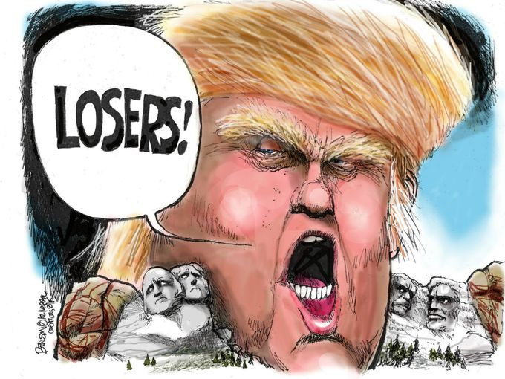
What is the issue highlighted in this political cartoon?

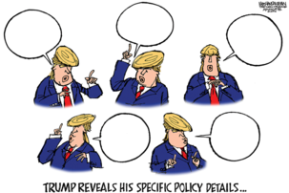
What is the issue highlighted in this political cartoon?

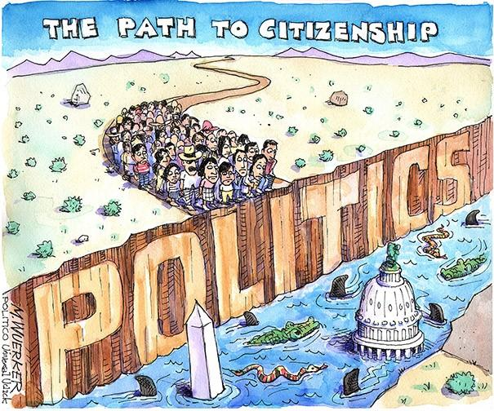
What is the issue highlighted in this political cartoon?

What is the issue highlighted in this political cartoon?

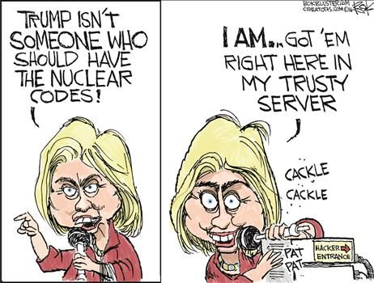
What is the issue highlighted in this political cartoon?

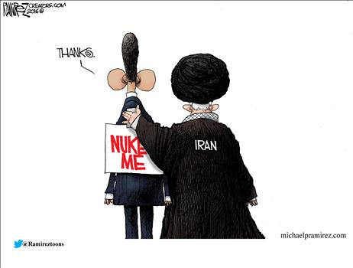

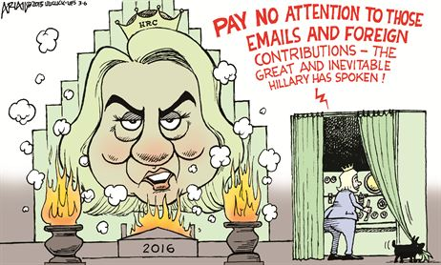

What is the issue highlighted in this political cartoon?

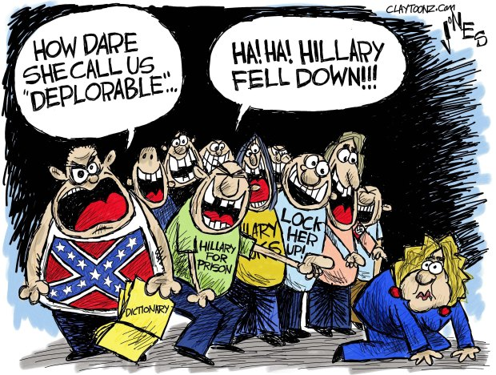

What is the issue highlighted in this political cartoon?

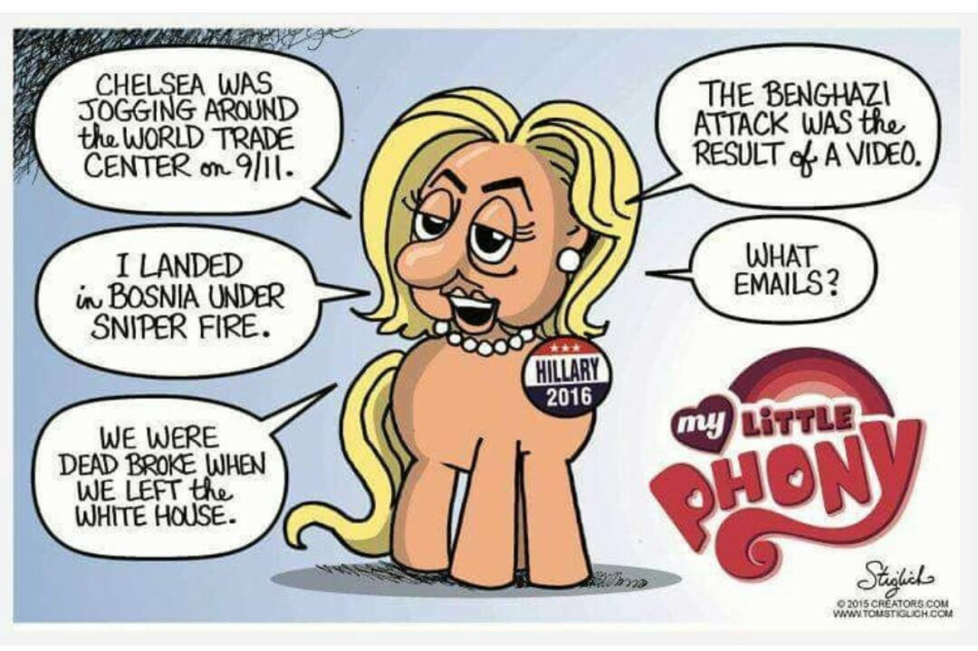
What is the issue highlighted in this political cartoon?

Period Political Cartoons:

Thomas Nast Background: (September 27, 1840 – December 7, 1902) was a German-born American caricaturist and editorial cartoonist who is considered to be the "Father of the American Cartoon". He was the scourge of Boss Tweed and the Tammany Hall political machine. His political cartoons were instrumental in bringing Boss Tweed to justice.

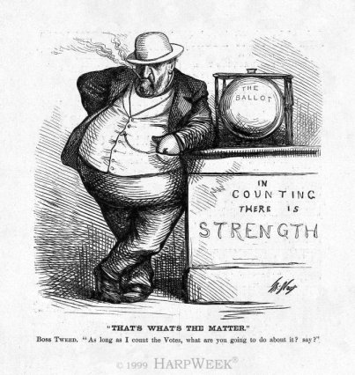
Text: “That’s What’s The Matter.”
“As long as I count the votes, what are you going to do about it? Say?

What is the issue Nast is highlighting in this political cartoon?

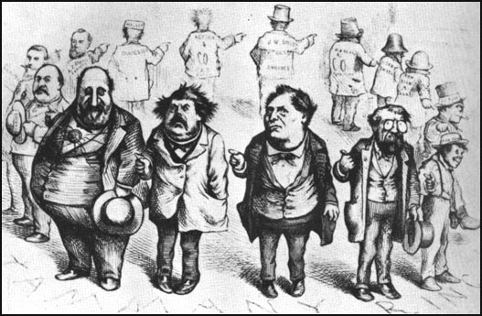
Text: “Who Stole the People’s Money? Do Tell…”

What is the issue Nast is highlighting in this political cartoon?

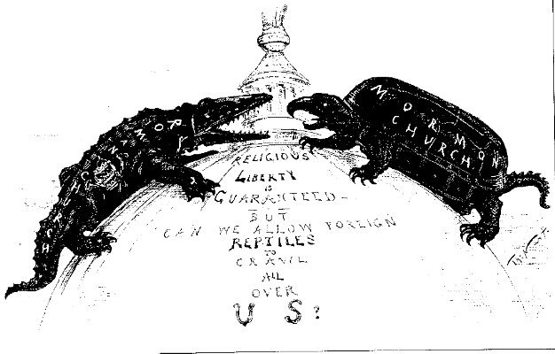
Text: Religious Liberty is Guaranteed—But Can We Allow Foreign Reptiles to Crawl all over US?

What is the issue Nast is highlighting in this political cartoon?

What is ironic about classifying the Mormon Church as a “foreign reptile?

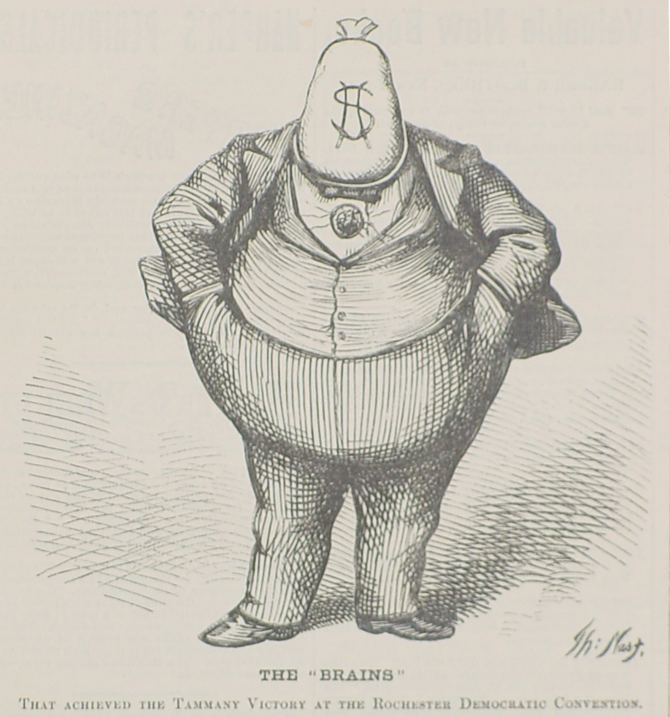
Text: The “Brains.” That Achieved The Tammany Victory at the Rochester Democratic Convention.

What is the issue Nast is highlighting in this political cartoon?

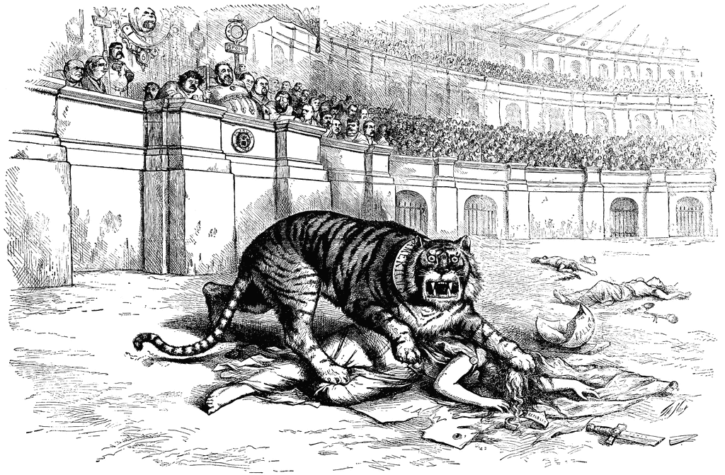
Text: “The Tammany Tiger Loose—What Are You Going To Do About It?”

What is the issue Nast is highlighting in this political cartoon?

