Calvin & Staheli Name __________________________________________ Date _________________________ Period _____________
US History
Pacific Theater Maps
Map 1:

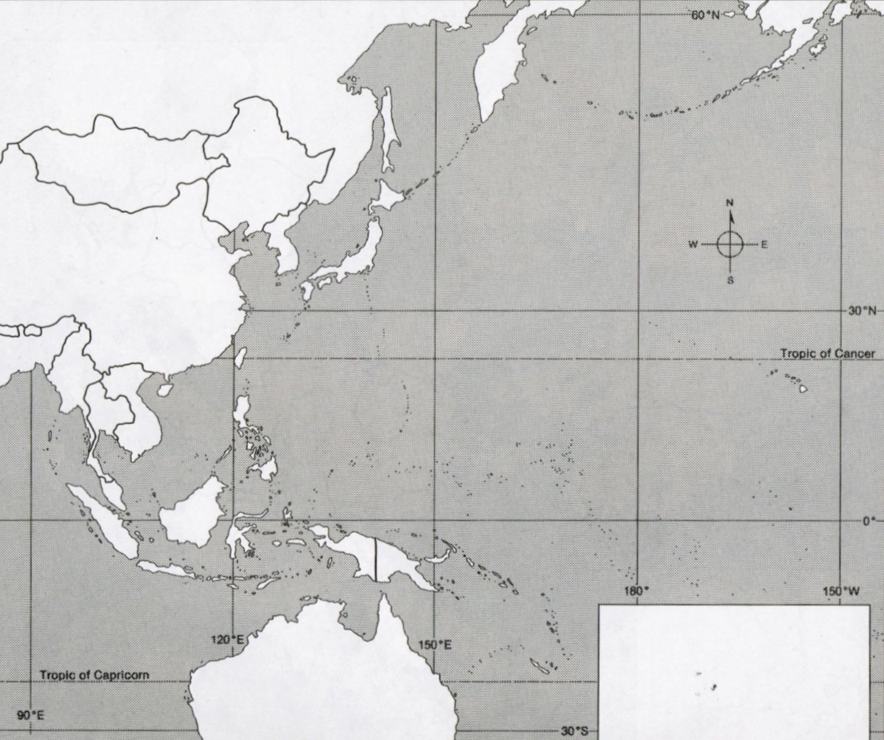

Map 1:Countries and cities:

- China
- French Indochina
- Thailand
- Burma
- Dutch East Indies (Indonesia)
- Malaya
- Solomon Islands
- Marshall Islands
- Mariana Islands
- Gilbert Islands
- Singapore
- Beijing
- Nanjing
- Tokyo
- Manila
- Korea
- Manchuria
- Mongolia
- New Guinea
- Australia
- Soviet Union (Russia)
- Japan
- Philippines
- Hong Kong

- USA (Alaska, Hawaii)
Map 2:
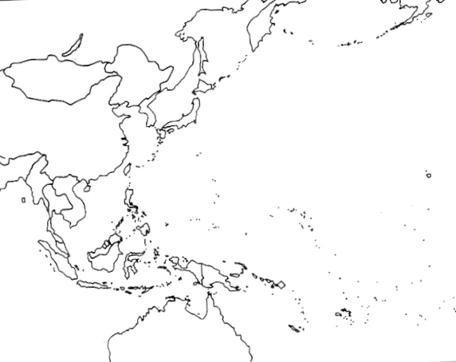

Map 2: Battles

- Midway Island
- Wake Island
- Coral Sea
- Guadalcanal
- Tarawa
- Guam
- Saipan
- Leyte Gulf
- Iwo Jima
- Okinawa
- Hiroshima
- Nagasaki
- Furthest Japanese advance into the Pacific (with a line or shading)
- Trace the advance of the Island Hopping Campaign (2 Separate trajectories)
- Allied Nations

