U.S. History Name:______________________________________ Date _________________________________Period:________

Vietnam War Map
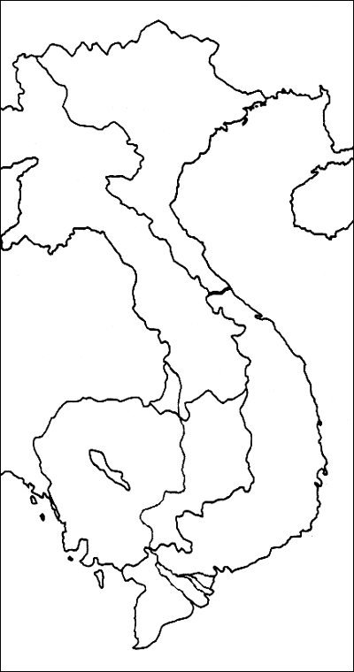

Directions:

Color the countries and use the “master” map in on the class blog to label the map with the following information:

Saigon (Ho Chi Minh City)
Hanoi
Gulf of Tonkin
Gulf of Thailand
South China Sea
Hainan
Danang
Hue
My Lai
Khe Sanh
Haiphong
Dien Bien Phu
Ho Chi Minh Trail
Cambodia
Phnom Penh
Laos
Thailand
China
Burma
Hong (Red) River
Mekong Delta
South China Sea

