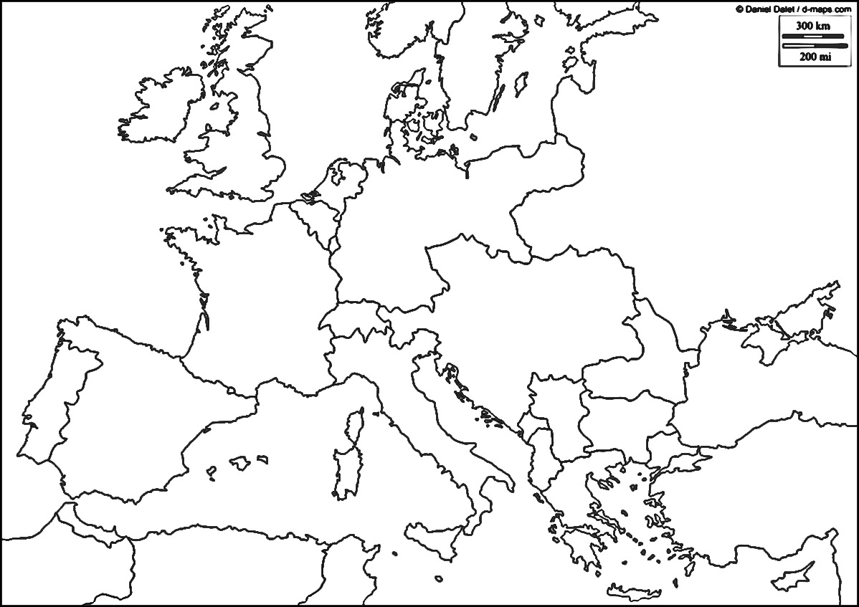

**COLOR:** Central Powers, Allied Powers, Neutral Nations

**LABEL THE FOLLOWING:**

Ireland

France

Montenegro

Serbia

Great Britain

Italy

Albania

Romania

Belgium

Greece

Russia

Germany

Ottoman Empire

Sweden

Switzerland

Austria-Hungary

Spain

Norway

Portugal

Bulgaria

Denmark

Battle of the Marne

Battle of the Somme

Battle of Ypres

Battle of Verdun

Western Front Trench Line

Allied Powers, 1916 Neutral Countries

Central Powers, 1916 Include Battles Name:_____________________________________ Period::__________

Neutral Countries