Name ____________________________________________________________ Date ________________________________________Period _________
US History
WWII European Theater – Map 1
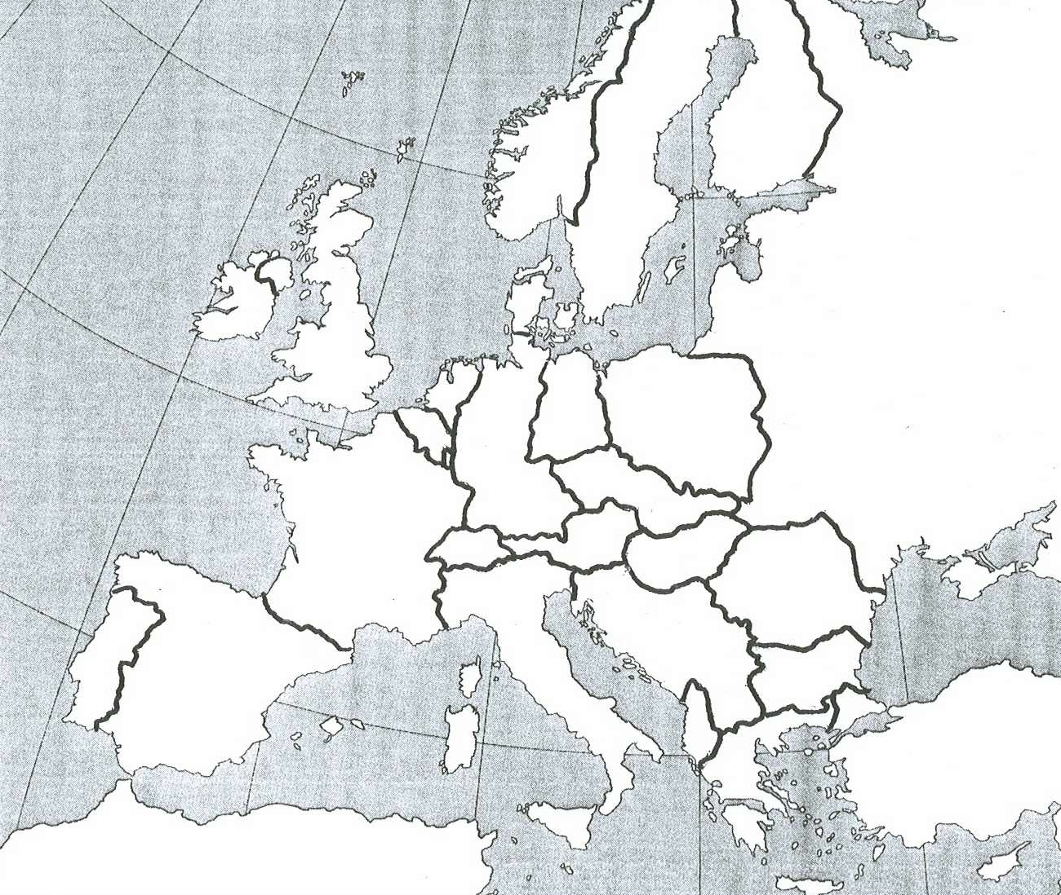

Map 1:
-Label All Countries
-Color Axis/Allied Countries (at the height of Axis control – 1942)
-Color Vichy territory
-Color Neutral Countries

Map 2:
-Label All Countries
-Trace Allied Movement in Operation Torch
-Label Kasserine Pass
-Label Casablanca, Oran, Algiers
-Color Allied and Axis Territory AFTER Torch

Map 3:
Label:
-Normandy (the region)
-Paris
-London
-Calais
-Allied Beaches collectively
-Trace Allied Movements June – August 1944

Map 4:
Label:
-All Countries
-Bastogne
-Antwerp
-Siegfried Line
-Ardennes Region
-Nazi Offensive movement on Dec. 16, 1944

Operation Torch – Map 2
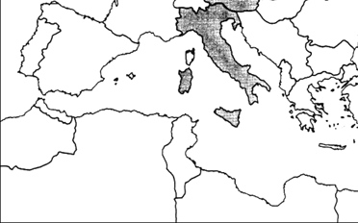

Operation Overlord – Map 3
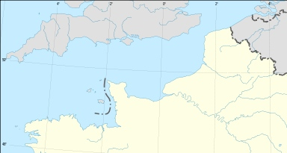

Battle of the Bulge – Map 4
